Melbourne Yacht Club
1202 East River Drive
Melbourne, FL 32901
PHRF Rating Application

Owners Name Address Phone No E-Mail Boat Vendor / Model Sail Number Boat Name

MYC Rating (to be entered by MYC PHRF Committee)

Boat Data and Measurement (in decimal feet):
I | PY | Spinnaker Girth
J | EY | Spinnaker Leach
P | LOA – Overall Length | Spinnaker Pole
E | LWL – Waterline Length | Draft
LP (Largest Headsail) | Beam | Displacement

Check all applicable boxes:
Rig | Keel | Rudder | Engine | Prop Install | Prop Type
□Masthead | □Fin Wing | □Attached | □Inboard | □In Aperture | □Folding
□Fractional | □Full | □Skeg | □Outboard | □Exposed Shaft | □Feathering
□Roller Furled Jib | □Center Board | □Spade | □None | □Strut Drive | □Solid 2-blade
□Dacron Main &Jib | □Drop | □Outboard |  |  | □Solid 3-blade
□Standard
□Tall

I hereby grant permission to the Measurer duly appointed by MYC to measure my boat in my presence to determine my rating if necessary.

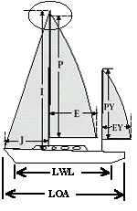
Date:
Owners Signature:

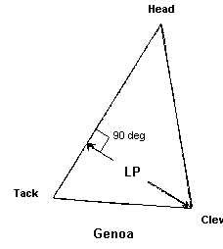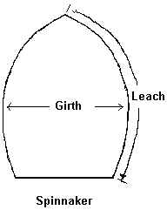

MYC Rating Application Liability Waiver

I recognize that the MYC Rating Committee’s sold purpose in issuing a rating Handicap for my boat is to estimate the relative speed between boats and assign Handicaps accordingly.

I understand that the assignment of a Handicap for my boat by the Rating Committee does not in any way constitute a representation or warranty by the Rating Committee that my boat is designed, rigged, equipped, maintained, crewed or operated in a manner that is safe and seaworthy for the races that I may enter using this Handicap. I acknowledge and agree that it is my sole responsibility for the safety of my boat and crew in the wind, sea and other environmental circumstances encountered while using the boat.

In consideration of my being granted a rating by the MYC Rating Committee and recognizing that the Rating Committee may not have the opportunity to either measure or inspect boats prior to issuing handicaps, I hereby affirm that I have examined all of the available information relating to the design and equipment of my boat and certify that it is seaworthy.

Signature Date

Complete and mail this form to: Del Wiese
MYC PHRF Rating Chairman 520 Eleuthera Lane
Indian Harbour Beach, FL 32937 phone 321.773.4884

